**Section 4: Enlightenment of Buddha Gotama- at Age of 35**

Tradition says that the Blessed One was enlighten in the year 589 B.C. at Bodh-gaya (then Uruvela) on a full moon day of month of May (Vesākha -Vesak) [1] .In this section we are going to focus on some important events prior to and following the noble enlightenment of the Blessed One.

**▲ Events Prior to Enlightenment:**

Earlier (section 3) we have seen how Ascetic Siddhartha gave up his extreme austerities—reflected on his meditative attainments at the age of seven, through his wisdom realised the way for liberation and prepared himself to gain physical strength to achieve it [2]. By this time the five group of ascetics who were attending to the bodhisatta were not happy about his new mode of practice, left him and went to the Deer Park at Isipatana [3]. The Bodhisatta stayed in the River Bank of Neranjana, in solitude and resolute, determined to strive for enlightenment! In the following sutta we can see how he defeated Mara and realized the noble state called ‘superhuman distinction in knowledge and vision worthy of the noble ones’ (*alm-ariya nanadassana vesesana*) [4]

♦ **Five Great Dreams**

In the following sutta the Buddha described the five dreams appeared to him before his enlightenment thus:

“*Bhikkhus, before his enlightenment, while he was just a bodhisatta, not fully enlightened, five great dreams appeared to the Tathāgata, the Arahant, the Perfectly Enlightened One. What five?”*

1) he dreamt that this mighty earth was his bedstead; the Himālaya, king of mountains, was his pillow; his left hand rested on the eastern sea, his right hand on the western sea, and his two feet on the southern sea—the dream, represented his awakening to the unsurpassed, perfect enlightenment.

2) he dreamt that a grass called *tiriyā* rose up from his navel and stood touching the sky —the dream showing that he would awaken to the noble eightfold path and would proclaim it well among devas and humans.

3) he dreamt that white worms with black heads crawled from his feet up to his knees and covered them—the dream showing that many lay followers would follow his teachings.

4) he dreamt that four birds of different colours came from the four quarters, fell at his feet, and turned all white—the dream showing that members of the four classes—

khattiyas, brahmins, vessas, and suddas—would go forth from the household life into homelessness and become his disciples.

5) he dreamt that he climbed up a huge mountain of dung without being soiled by it—the dream showing that he would receive the four requisites to sustain the homeless life and he would use them without being tied to them, infatuated with them, and blindly absorbed in them, seeing the danger and knowing the escape [5].

**Note:** These dreams are like foretoken (pubbanimitta) indication that the bodhisatta would gain the Buddhahood in the near future.

**♦ Encounters with Māra** [6]

On the occasion when the bodhisattva was sitting in meditation under the *assattha* bo-tree [7], in the bank of Neranjana river, Māra wanted to discourage bodhisattva from attending liberation, wanted to hold him in his grip. Below we can see a passage from Suttanipata, how the Māra, was trying to persuade the Bodisatta away from Buddhahood.

The Buddha elaborates this event thus:

“As I strove to subdue myself  
beside the broad Nerañjarā,  
absorbed unflinchingly to gain  
the surcease of bondage here,  
Namucī came and spoke to me  
with words all garbed in pity thus:

**Māra**

‘…you are thin and you are pale,  
and you are in death’s presence too:

a thousand parts are pledged to death  
but life still holds one part of you.  
Live, sir! Life’s the better way;  
you may gain merit if you live,

come live the life of purity, pour  
libations on the holy fires  
and thus a world of merit gain.  
What can you do by struggling now?

The path of struggling too is rough,  
and difficult and hard to bear…’

**The Bodhisatta replied**:

O Evil One, O Cousin of the Negligent,

you have come here for your own ends.

Now, merit I need not at all.   
Let Māra talk of merit then,  
to those that stand in need of it.

For I have faith and energy,  
and I have understanding, too.  
So while I thus subdue myself,  
why do you speak to me of life?

There is this wind that blows, can dry  
even the rivers’ running streams;  
so while I thus subdue myself,  
why should it not dry up my blood?

And, as the blood dries up, then bile  
and phlegm run dry, the wasting flesh  
becalms the mind: I shall have more  
of mindfulness and wisdom too,  
I shall have greater concentration.

For living thus, I come to know  
the limits to which feeling goes.  
My mind looks not to sense-desires:  
Now see a being’s purity…” [8]

Having understood the unshakeable determination of the bodhisattva, and that he has no power to defeat him, with a heavy heart Māra went away.

**Note: \*** The Dhamma message presented here is that unwavering effort is essential to tread on the spiritual path. The Right Effort (samma vayama), as outlined in the Eightfold Noble Truths, is vital for spiritual growth: right effort to eliminate existing evils, to prevent existing evils from arising, to enhance the existing merits, and to continue to acquire new merits. This is one of the essential factors-helping hand to achieve the goal.

* Tradition says that in the morning of the day of enlightenment the bodhisatta partook milk rice offered by a maiden named Sujata, daughter of householder of nearby Senani village. Though the scriptures have no record of this event we can see a reference to her in the AN1: 258, the Blessed One declaring: *“…****the foremost of my female lay followers in being the first to go for refuge is Sujātā****, daughter of Senānī*”. (She offered the bodhisatta his last meal before his enlightenment see: AN: Notes: 139). [9]. In Mahaparinibbana sutta (DN:16)there is a statement about alms offering to the Buddha:

*“…****that these two alms-givings’*** *are of very great fruit, of very great result, more fruitful and advantageous than any other. Which two? The one is the alms-giving after eating which the Tathāgata attains supreme enlightenment, the other that after which he attains the Nibbana-element without remainder at his final passing”.* As we know from the sutta that Cunda offered the last meal. It is not mentioned here that who had offered the first meal? If we go by legend, we can assume that Sujata offered the meal to the Buddha to be before his supreme enlightenment!

If we ponder little further about the Buddha ‘s statement regarding Sujata being the foremost lay woman to go for refuge to him, we may see her as the fist woman who paid homage to the Buddha after his enlightenment? AN1 (XIV Foremost Chapter) all the others described there were persons who have gone to the refuge of the Buddha after his enlightenment. In the case of Thapassu and Ballika two brothers mentioned in AN1:248. thus: “*Bhikkhus, the foremost of my male lay followers in being the first to go for refuge are the merchants Tapussa and Bhallika”.* According to Vinaya Pitaka :“…*When Tapussa and Bhallika knew that the Buddha had finished his meal, they bowed down with their head at his feet, and said, “Sir, we go for refuge to the Buddha and the Teaching. Please accept us as lay followers who have gone for refuge for life.” By means of the double refuge, they became the first lay followers in the world”.* [10] Hence, whether Sujata was paying respect to the bodhisatta and offered him his last meal or she was bowing down to the newly enlightened Buddha and offered him the first meal is uncertain.

**▲ Supreme Enlightenment -Samma Sam Bodhi**

The Bodhisattvas, with a strong determination to attain liberation, increased his velour; through his effort and unwavering heedfulness, he strove and won the battle with Māra and his tenfold army, and attained the supreme enlightenment. [11]

♦ **The Blessed One describes his effort and determination as thus:**

*“…bhikkhus, …I strove indefatigably… ‘willingly, let only my skin, sinews, and bones remain, and let the flesh and blood dry up in my body, but I will not relax my energy so long as I have not attained what can be attained by manly strength, energy, and exertion.’ It was by heedfulness that I achieved enlightenment, bhikkhus; it was by heedfulness that I achieved the unsurpassed security from bondage…”. [12]*

**“…being myself subject to birth… ageing… sickness … death…sorrow…and defilements…I attained the supreme security from bondage, Nibbāna. The knowledge and vision arose in me: ‘My deliverance is unshakeable**

**This is my last birth; now there is no renewal of being’”.MN: 26: The Noble Search**

**Enlightenment**

S.D

4/16/05

***♦* Full Enlightenment**

In the following suttas the Blessed One stated about his enlightenment:

*\* “...I am now the Arahant and fully enlightened Buddha, am of the Gotama clan…I became fully enlightened at the foot of an assattha-tree…” [13]*

*\* “Then, bhikkhus, being myself subject to birth…ageing…sickness…death having understood the danger in what is subject to birth, ageing…sickness…death…seeking the unborn… unageing… unailing …deathless supreme security from bondage… I attained the… supreme security from bondage… Nibbāna… I attained the sorrowless… undefiled… supreme security from bondage, Nibbāna. The knowledge and vision arose in me: ‘My deliverance is unshakeable; this is my last birth; now there is no renewal of being.’”[14]*

♦ **The Path to Enlightenment**

After he had become fully enlightened, the Buddha reflected on the path that led to his awakening. As he was dwelling at Uruvelā on the bank of the river Nerañjarā at the foot of the Goatherd’s Banyan Tree he thought:

“*I am indeed freed from that gruelling asceticism! It is good indeed that I am freed from that useless gruelling asceticism! It is good that, steady and mindful, I have attained enlightenment!”* [15]

Having known as useless any austerity

Aimed at the immortal state,

That all such penances are futile

Like oars and rudder on dry land,

By developing the path to enlightenment—

Virtue, concentration, and wisdom—

I have attained supreme purity:

You are defeated, End-maker.

**Quote from** SN:4: 1 (Austere Practicesutta)

**Note:** Māra is called the End-maker (*antaka*) because he binds beings to death. (see: SN: Note: 265).

**▲ What is Full Enlightenment? – Definition of Samma Sambuddha**

Samma Sam Buddha is one of the nine noble qualities attributed to Tathāgata. The nine qualities are:

*“…the Blessed One is an arahant, perfectly enlightened, accomplished in true knowledge and conduct, fortunate, knower of the world, unsurpassed trainer of persons to be tamed, teacher of devas and humans, the Enlightened One, the Blessed One.’[16]*

When we see all the nine noble qualities attributed to the Blessed One, we could include all of them in to one term—The Fully Enlightened One (Samma Sam Buddha). We can justify that claim by looking into noble nine qualities mentioned above:[17]

1) **Arahant—**accomplished: Arahant: he has been freed from all the defilements of the worldly life; broken the cycle of samsara; abolished rebirth; and worthy of worship and respect from gods and humans[18]

2) **Samma Sam Buddha**— The Fully Enlightened One: he has discovered (buddha) all things rightly ( sammā) and by himself (sāmam), he fully understood the Four Noble Truths; he awakened from the great sleep of delusion; he attained the knowledge of omniscience.

3) **Vijjācaraņa sampanno** -Endowed with clear vision and virtuous conduct:

The scriptures mentioned three kinds of clear vision (knowledges) (*te-Vijja*—Three knowledges) and also eight kinds of knowledges: **Three Knowledges**: 1. knowledge of the recollection of past lives (*pubbe-nivāsāussati ñāņa*) 2. knowledge of the passing away and reappearance of beings (*dibba-cakkhu*) 3. knowledge of destruction of all taints ( *āsavakkhaya ñāņa*) [19]

**Eight kinds of knowledges—**1-3 as mentioned above, 4. Insight knowledge (*vipassana*) 5. Magical powers (*iddhi-vidhā*) 6. Penetration of the mind of the others *(ceto-pariya-ñāņa)* 7. Divine ear (dibba-cakkhu) 8. Mind-made-body (manōmaya kaya) Ability to create from this body another body [20]

**Fifteen virtuous conducts— caraņa:** 1. perfected in morality 2. guardian of the sense-doors

3. accomplished in mindfulness and clear awareness 4. Contentment 5. Moderation in eating

6. Wakefulness 7. Faith 8. shame (*hiri*) & fear of wrongdoing (*ottappa)* 9. Learned much 10. Energetic 11. Wisdom 12-15. The four jhānas [21]

**Note:** The Buddha after describing the knowledge and conduct of noble ones said: *“…and beyond this there is no further development of knowledge and conduct that is higher or more perfect…”: DN:4*.

4)  **Sugata-** Sublime: Because he has reached Nibbana through the path of the Arahant, and has been practicing the principles of the Ariya path since his Bodhisattva days, because he has a beautiful form, because he has a beautiful journey, because he has entered the beautiful place of Nibbana, and because he preaches the Dhamma in the voice of Brahma, he is called sublime one-Sugatha [22]

5)**Lokavidu**- Knower of the world: he knows the three worlds fully, has seen the world fully, knows the extent of the world, knows how to end the world.

6) **Anuttaro purisadammasarathi** -Incomparable leader of men to be tamed: he surpasses the whole world with his noble qualities hence there is no one to compare him (only equal to a another Samma Sam Buddha), he tames men to be tamed with great compassion and highest wisdom.

7) **Sattha deva manussa-** Teacher of gods and men: Like the caravan teacher he guides beings across the wildness of samsara safely.

8) **Buddha**-Enlightened: he knows the fruit of liberation, awakened from the delusion of the world.

**Note**: In the following sutta Buddha elaborate this title:

*What must be known is directly known,*

*What must be developed has been developed,*

*What must be abandoned has been abandoned,*

*Therefore, brahmin, I am a Buddha.*

*‘‘Abhiññeyyaṃ abhiññātaṃ,*

*bhāvetabbañca bhāvitaṃ;*

*Pahātabbaṃ pahīnaṃ me,*

*tasmā buddhosmi brāhmaṇa* MN:92.

* In the following sutta also we can see why a Fully Enlightened Being is called the Buddha:

“As a lovely white lotus

is not soiled by the water,

I am not soiled by the world:

therefore, O brahmin, I am a Buddha.”

AN:4:36 (Dona sutta)

9) **Bhagava-** Blessed: it is the best of the words, finest word, term for veneration and respect, fortunate one, liberated one, developed one.

Going through all those noble qualities we could see that Samma Sam Buddha carry all those traits within him. In the following sutta we can get a glimpse of what is a Fully Enlightened One!

The Buddha said:

*I am the one whose presence in the world*

*Is very rarely come upon,*

*I am the Fully Enlightened One, I,*

*O brahmin, am the supreme physician.*

*‘‘Yesaṃ ve dullabho loke,*

*pātubhāvo abhiṇhaso;*

*Sohaṃ brāhmaṇa sambuddho,*

*sallakatto anuttaro.*

*I am supreme king of the Dhamma;*

*By means of the Dhamma I turn the wheel,*

*The wheel that none can stop.*

*‘‘Rājāhamasmi selāti,*

*dhammarājā anuttaro;*

*Dhammena cakkaṃ vattemi,*

*cakkaṃ appaṭivattiyaṃ’’.*

MN: 95.

The Buddha is the noble one who himself discovered the path to enlightenment. He has no teacher, he declares that path for the happiness of all the beings. From the following statement by Venerable Ānanda confirmed this:

*“…the Blessed One, accomplished and fully enlightened. For the Blessed One was the arouser of the unarisen path, the producer of the unproduced path, the declarer of the undeclared path; he was the knower of the path, the finder of the path, the one skilled in the path…”.*

MN:108

With all the testimony stated above, we can confirm that the presence of a Samma Sam Buddha in the world is extraordinary thing! A significant thing! **Why is that?**

Appearance of a Buddha in a world is amazing and very rare thing. According to Mahâpadāna Sutta (DN:14) during the last ‘ninety-one aeons’ of time period, only seven Buddhas appeared in the world! Buddhas appear at vast intervals of time and rest of the long, long period the world is Buddha-less (*abuddhassa*)! Because of none appearance of Buddha the world is merge in darkness of ignorance! Perhaps not a pleasant place to be.

The other important factor is only the fully-enlightened Buddhas are capable of teaching Dhamma: to lead devas and humans towards the freedom from Samsara suffering. According to scriptures time to time Pacceka-Buddhas (solitary buddhas or private buddhas) who are enlightened noble ones appears but they are not able to teach Dahmma or to establish dispensation to flourish Dhamma (which would thrive even after the passing away of a Samma Sam Buddha).

Samma Sam Buddha is the supreme physician who would attends to worldly illness, through his universal compassion and deep wisdom about the world, he could give proper treatment to cure worldly illness. According to Dhammachakkapavthvana sutta, only the

Samma Sam Buddha could role the ‘Wheel of the Dhamma’ —no other being can stop! Once, rolled it would keep on rolling till the dispensation of the Buddha vanished form the earth.

This encourage and comfort the followers of the Blessed One, that they could still live in an era where the Dhamma proclaimed by the Buddha is available, even now in this 21st century! We can see that we are fortunate, we have some idea of the Buddha and his teaching and we also established in faith of the Triple Gem to follow the Dhamma. Therefore, we have a choice, either we would follow his guidance, and practice as lay followers and develop wholesome activities in order to live peacefully and happily in this life and lives to come! Or if we have more wisdom and courage, we can be monastics and enhance our spiritual life, extend support to other beings by spreading the good Dhamma, proclaimed by the Blessed One, our Teacher, the Buddha Gotama. That is the only way we can honour and repay the Blessed One who by his own wisdom and effort got break through and showed us the true way. Later in this compilation we can see his untiring service to the world from age 35 to 80, till his final passing away. Samma Sam Buddha is the one who has proper and complete understanding of the entire humanity-the entire world and who could guide beings safely across to the other shore.

**▲ Events occurred soon after the Enlightenment**

In here we would like to present a few selected incidents happened after the Buddha’s attainment of Nibbāna. It is important to have some knowledge of them as we could see how the newly enlightened Buddha faced the world! These things also would keep us alert in the snares of worldly things waiting behind us to take us out from the spiritual path. There is no one in the three worlds who could trap the Samma Sam Buddha into sensual world. However, those who desire to develop spirituality has to be aware of such traps.

**♦ Encounters with Māra and Mara’s daughter’s**

After the bodhisattva became fully enlightened Buddha, the Māra again visited the Blessed One when he was dwelling immersed in the bliss of samādhi, at Uruvelā on the bank of the river Nerañjarā at the foot of the Goatherd’s Banyan Tree. Māra was not sure about the bodhisattva’s supreme liberation, so he approached the Buddha and said:

“Having deviated from the austere practice

By which men purify themselves,

Being impure, you think you’re pure:

You have missed the path to purity”

**The Blessed One replied:**

“Having known as useless any austerity

Aimed at the immortal state,

That all such penances are futile

Like oars and rudder on dry land,

By developing the path to enlightenment—

Virtue, Smādhi, and wisdom—

I have attained supreme purity:

You’re defeated, End-maker!” [23]

At the end, Māra realising that he is not able to catch the Buddha in his snare, defeated and disappointed went away like a crow, who attacked a piece of stone thinking it was tasty food. [24]

**Daughter’s of Māra tried to snare the Blessed One**

According to scriptures, Māra having disappointed and saddened by his defeat went away and sat not far from where the Buddha sat. At this point, his daughters, Taṇhā, Aratī, and Ragā came to him and inquired regarding the reason for his dismay and sadness. Māra said this:

*“The Arahant, the Fortunate One in the world, … has gone beyond Māra’s realm: therefore, I sorrow so bitterly.” [25]*

Then the three daughters assured their father that with their beauty and charm they could catch him:

*“ …we will catch him with the snare of lust, as they catch the forest elephant, we will bind him tightly and bring him back, and he will be under your control…”.*

So, the three daughters of Māra went near the Blessed One and addressed him with sweet and charming voices:

“*We serve at your feet, ascetic*…”

The Blessed One who has gone beyond lust, hate and delusion, did not pay any attention to them. They were so amazed that they could not captured the attention of the Buddha by their beauty, their lustful singing and dancing. They, talked among themselves of their failed actions:

*“If we had assailed with such tactics any ascetic…who was not devoid of lust, either his heart would have burst, or he would have vomited hot blood from his mouth, or he would have gone mad or become mentally deranged… what our father told us is true…”*

Failed to trap the Blessed One in their snare, the daughters departed with disappointment.

At the end of the sutta there is a statement to this effect:

*“They had come to him glittering with beauty-*

*Taṇhā, Aratī, and Ragā-*

*But the Teacher swept them away right there*

*as the wind, a fallen cotton tuft”[26]*

**♦ Dhamma lessons to be learn from this event**:

1) Establishment of Right View is important in the Spiritual Path 2) to understand the uselessness of practicing austerities for spiritual development. Here we can see that from his own experience the bodhisatta, learned to abandon the wrong view as soon as he realised it, he dropped the obscure practice and straighten his right view. This experience cautions us to avoid the wrong views if we wish to develop our spiritual practice and follow the Right View disclosed by the Buddha. If one would wish to enhance the Dhamma, and to blind fold Māra, one must keep in mind what the Buddha said and practice accordingly.

By developing the path to enlightenment—

Virtue, concentration, and wisdom—

I have attained supreme purity:

You’re defeated, End-maker! [27]

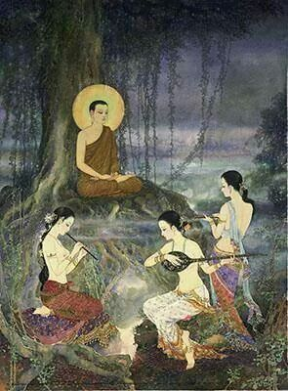

**Māra’s three daughters attempt to seduce the Buddha**: Picture courtesy: https://au.pinterest.com/

**▲ Peaceful abiding’s soon after the enlightenment**

According to Vinaya Pitaka [28] soon after the enlightenment, the Blessed One stayed near the river bank of Neranjana in meditative bliss for seven days in one place and moving to another and spending seven days etc. Summery of that time period is given below:

**First week**: Foot of the Bodhi Tree reflecting on Dependent origination.

**Second week**: Foot of the Goatherd’s banyan tree where the Buddha had an encounter with a brahmin from a near by village.

**Third week:** Foot of the Powderpuff tree, where the Buddha had an encounter with Naga Mucalinda.

**Fourth Week**: Foot of the Ape-flower tree, Tapussa and Bhallika offered a meal to the Buddha and became lay followers (taking refuge in Buddha and the Dhamma), also deva’s offering the first almas bowl.

**Fifth week:** Foot of the Goatherd’s banyan tree, reflecting on the profundity of the Dhamma, not inclined to teach Dhamma, and invitation of the Bahama Shampti to teach, consented to his invitation, and looking for people to teach.

**Note:** * There is no mention of the seventh week, but the VP says “Then, after staying at Uruvelā for as long as he liked, he set out wandering toward Benares (to teach the five group of ascetics).

* **However, popular Buddhist Tradition says** that soon after his enlightenment, the Blessed One spent seven weeks near the river bank of Neranjana—the place of enlightenment (now called Bodh Gaya): The seven weeks are described thus:

**First week:** Under the Bodhi tree. **Second week**: The Buddha in gratitude to the Bodhi Tree for its support during his enlightenment, gazed at the bodhi tree. This is called ‘animisa lochana puja’. Following his example, the Buddhists pay respect to the Bodhi tree. **Third week**: Buddha saw in his mind that devas in the heavens were not sure of his Buddhahood, hence he created a golden bridge in the air and waled up and down. This is called ‘Ruwan sakmana’. **Fourth Week**: The Buddha created a beautiful jewelled chamber, sat inside it and meditate; six colours of rays—blue, yellow, red, white, orange and mixture of the five colours. ( it says each colour represents the noble qualities of the Blessed One: blue=confidence, yellow=holiness, red=wisdom, white= purity, orange=desire lessness and the mixed colour= representing all noble qualities of the Budda. Note: The Buddhist flag displayed by Buddhists during religious ceremonies represent all those colours). **Fifth week**: Meditating under the Banyan tree, encounter with the three daughters of Māra. **Sixth week**: Meditating under the Midella tree, encounter with Muchalinda Naga. **Seventh week:** Sat under Rajayatana tree and meditate. After seven weeks of fasting the Buddha received a meal from Tapussa and Bhallika, two merchants. They became the first lay followers. (it says they asked the Buddha to give something to remind them of the Buddha and he gave a lock of his hair- Kesa Datu. The merchants returned home in Burma and made a chetiya called Shwedagon Pagoda (in Rangoon) [29].

**Important Dhamma revealed during that period**

♦ **The** **Cycle of Dependent Origination- Core Teaching of the Buddha**

**Vinaya Pitaka says:** “soon after his awakening the Buddha staying at the bodhi tree [30] experiencing the bliss of liberation from all suffering, was reflecting on Dependent Origination-DP (*patītychcha samuppāda*) in forward and reverse order…” [31]

*“…ignorance is the condition for intentional activities; intentional activities are the condition for consciousness; consciousness is the condition for name and form … this is how there is the origin of this whole mass of suffering. … this is how there is the end of this whole mass of suffering…” [32]*

* In the following sutta we can see how the Blessed One shared his experience and knowledge of DP with his disciples:

*“Bhikkhus, before my enlightenment, while I was still a bodhisatta… it occurred to me: ‘Alas, this world has fallen into trouble, in that it is born, ages, and dies, it passes away and is reborn, yet it does not understand the escape from this suffering [headed by] aging-and-death. When now will an escape be discerned from this suffering [headed by] aging-and-death?’*

*“…then, bhikkhus, it occurred to me: ‘When what exists does aging-and-death come to be? By what is aging-and-death conditioned? Then, bhikkhus, through careful attention, there took place in me a breakthrough by wisdom: ‘When there is birth, aging-and-death comes to be; aging-and-death has birth as its condition.’* [33]

**(**meaning is that the penetration of aging-and-death occurred thus, “When there is birth, aging-and-death comes to be) [34]

In the same sutta we can see how the Buddha described that all factors of DP: ignorance…etc depending on each other, originating the whole mass of suffering, and when those factors are not there how the suffering cessed. He was showing us how reflecting on this matter the full understanding came to him which led to his awakening:

“*Origination, origination’—thus, bhikkhus, in regard to things unheard before there arose in me vision, knowledge, wisdom, true knowledge, and light…” (cakkhu, ñāṇa, paññā, vijjā, and āloka)* [35]

**“***Thus, with the remainder less fading away and cessation of ignorance comes cessation of volitional formations; with the cessation of volitional formations, cessation of consciousness…. Such is the cessation of this whole mass of suffering. “‘Cessation, cessation’—thus, bhikkhus, in regard to things unheard before there arose in me vision, knowledge, wisdom, true knowledge, and light.”*

**The** **Conditioned phenomena** in DP above is described in the following sutta thus:

When this exists that come to be

With arising of this, that arise.

When this does not exist, that does not come to be;

with the cessation of this that ceases

*(imasmi.m sati ida.m hoti;  
imassuppaadaa ida.m uppajjati;  
imasmi.m asati ida.m na hoti;  
imassa nirodhaa ida.m nirujjhati)*

SN12: 49:

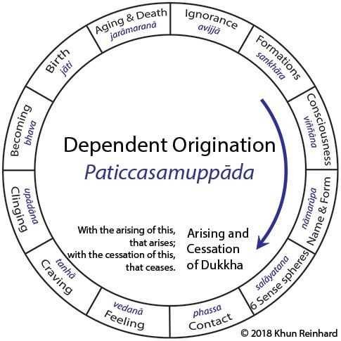

**12 Links of the Dependent Origination** -Central Concept in Buddhism: Courtesy <https://www.reddit.com/r/BuddhistMonastics/comments>

**Note:** * this is the first time **Dependent Origination** (DP) is mentioned in the scriptures (per Vinaya Pitaka)

**\*** In here, the Blessed One uttered his **first 3 Udanas’** (heartfelt exclamations) during his reflection on DP: A summary of the **3 Udanas**:

*“When things become clear to the energetic brahmin who practices absorption: then all his doubts are dispelled, since he understands the natural order and its conditions…ssince he’s understood the end of the conditions… he defeats the army of the Lord of Death, Like the sun beaming in the sky”* [36]

**\*** Occasionally people who are studying suttas ponder: whether the Budhha’s awakening happened while he was reflecting on DP as mentioned in Vinaya Pitaka? or the real breakthrough happened on the full understanding of the Four Noble Truths as mentioned in his first discourse? (see: **SN56: 11 (** Setting in Motion the Wheel of the Dhamma sutta). Here, what we have to point out is that the night of awakening as a ‘Fully Enlighted One’ – by himself through his great insight and deep wisdom, the Blessed One understood all the doctrines in the world. To stress this point we can look in to Sela Sutta (MN: 92) what the Buddha said to Brahamin Sela:

*What must be known is directly known,*

*What must be developed has been developed,*

*What must be abandoned has been abandoned,*

*Therefore, brahmin, I am a Buddha.*

“Very frequently, we find that the Buddha expressed His experience of enlightenment in one of two ways, either in terms of having understood the Four Noble Truths, or in terms of having understood the nature of dependent origination. Again, the Buddha has often mentioned that in order to attain enlightenment one has to understand the Four Noble Truths; or similarly, one has to understand dependent origination”.

**Quote from** <http://www.buddhanet.net/funbud12.htm>

♦ **Who is an Arahant?**

This also the very first time we see in the scriptures defining ‘who is an arahant?’

When the newly enlightened Buddha was spending his blissful time around Bodh Gaya, a brahmin from nearby village approached him and inquired of the qualities of a brahmin. The Blessed One described the qualities showing that a real brahmin is not any ordinary brahmin but an arahant:

*“ The brahmin who has shut out bad qualities, who is humble, free from flaws, and self-controlled, who has reached final knowledge and has fulfilled the spiritual life—he may rightly proclaim himself a brahmin, having no conceit about anything in the world”[37]*

**Arahant**

“Bhikkhus, … how is a bhikkhu an arahant? Evil unwholesome states that defile, bring renewal of being, give trouble, ripen in suffering, and lead to future birth, ageing, and death, are far away from him. That is how a bhikkhu is an arahant.”

*( Kathañca, bhikkhave, bhikkhu arahaṃ hoti? Ārakāssa honti pāpakā akusalā dhammā, saṃkilesikā, ponobbhavikā, sadarā, dukkhavipākā, āyatiṃ, jātijarāmaraṇiyā. Evaṃ kho, bhikkhave, bhikkhu arahaṃ hotī’’ti.)*

**Quote from**: MN: 39 (Mahā Assapura Sutta).

▲ **Important of Practicing Harmlessness & Kindness towards all Beings**

This is also an important message conveyed by the Blessed One during the first few weeks of his life after the Buddhahood. Scriptures mentioned an encounter taken place at that time: a Naga King called Muchalinda, who had seen the Buddha in deep meditation during a heavy storm gave him protection by wrapping his body with his serpent-coils and putting his hood over the head. When the Buddha came out from the meditation and realising what the Naga King did uttered the following Udana showing the important of harmless practice towards all living beings. This remind us of the Metta Sutta where the Buddha said that ‘spreading loving kindness to all beings’ is a quality important to tread on the Noble Path.

“*Seclusion is bliss for the contented*

*Who sees the Teaching that they have learned.*

*Kindness to the world is happiness,*

*For one who’s harmless to living beings.*

*Dispassion for the world is happiness,*

*For one who overcomes sensuality.*

*But removing the conceit ‘I am’,*

*This, indeed, is the highest bliss.”* [38]

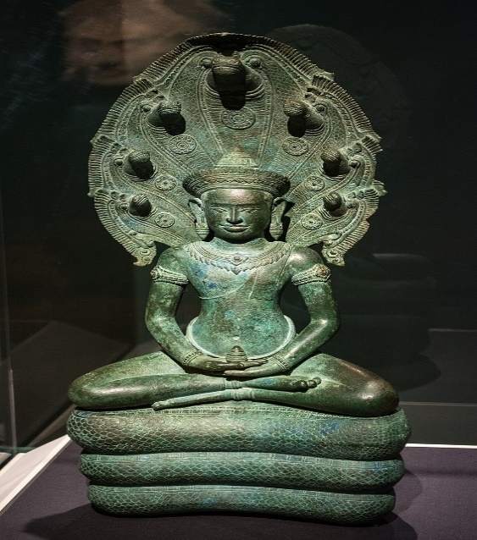**Note**: Apart from being harmless, in here we can see some other essential qualities supporting the spirituality such as seclusion, loving kindness (metta) to all, dispassion towards worldly things and abandon of conceit.

**Muchalinda Naga giving protection to the Buddha**

12th century Naga-enthroned Buddha Cambodia.

Picture courtesy: [Cleveland Museum of Art](https://en.wikipedia.org/wiki/Cleveland_Museum_of_Art): OH, USA.

▲ **To Honour the Dhamma**

On one occasion the Blessed One was dwelling at Uruvelā on the bank of the river

Nerañjarā at the foot of the Goatherd’s Banyan Tree just after he had become fully enlightened a reflection arose in his mind thus: [39]

*“One dwells in suffering if one is without reverence and deference. Now what ascetic or brahmin can I honour and respect and dwell in dependence on?...* *... I do not see another ascetic or brahmin more perfect in the knowledge and vision of liberation than*

*myself, whom I could honour and respect, and on whom I could dwell in dependence…“Let me then honour, respect, and dwell in dependence on this very Dhamma to which I have fully awakened.”*

**Note:** * Spk assigns this sutta to the fifth week after the enlightenment. The sutta is also at AN II 20-21 with an additional paragraph, see: SN:Notes: 373, p. 550.

* This shows the great wisdom and humility of the Buddha recognising the greatness of the Dhamma and sharing his experience with his disciples urging them to honour the Dhamma. This is a very important message to Buddhists- to understands the significant of the Dhamma- the teaching, he stressed this point on his last days of life conveying the important message – saying when the Buddha is no more – Dhamma will guide everyone. Hence, we Buddhist rely on Dhamma and live and practice according to Dhamma would never fall out from our spiritual path!, see: DN: 16 (Mahaparinibbana sutta)

**Dhamma should be revere**

Therefore, one desiring his own good,

Aspiring for spiritual greatness,

Should deeply revere the true Dhamma,

Recollecting the Buddhas’ Teaching

**Quote from:** SN6:2

▲**Profundity of the Dhamma**

Another significant Dhamma factor revealed during that time the Buddha was pondering of depth of the Dhamma he fathomed during the night of his awakening: understanding the causality (dependent origination) and giving up all attachments (abandoning greed -tanha) which led him to liberation. He reflected thus:

“*I have discovered this profound truth, so hard to see, so hard to comprehend. It’s peaceful and sublime, subtle, beyond the intellect, and knowable only to the wise…”* [40].

**Note: F**ollowing his reflection of the depth of the Dhamma, the Buddha felt that ordinary beings who are immersed in sensual pleasures would not be able to understand the realty and was hesitate to teach. This is what he thought:

‘*Enough with teaching the Dhamma*

*That even I found hard to reach;*

*For it will never be perceived*

*By those who live in lust and hate.*

*Those dyed in lust, wrapped in darkness*

*Will never discern this abstruse Dhamma*

*Which goes against the worldly stream,*

*Subtle, deep, and difficult to see”*

MN: 26

The Buddha describes the event:

“ …then, bhikkhus, the Brahmā Sahampati knew with his mind the thought in my mind and he considered: ‘The world will be lost, the world will perish, since the mind of the Tathāgata, accomplished and fully enlightened, inclines to inaction rather than to teaching the Dhamma.’

“…then, just as quickly as a strong man might extend his flexed arm or flex his extended arm, the Brahmā Sahampati vanished in the Brahma-world and appeared before me. He arranged his upper robe on one shoulder, and extending his hands in reverential salutation towards me, said:

“*Venerable sir, let the Blessed One teach the Dhamma, let the Sublime One teach the Dhamma. There are beings with little dust in their eyes who are wasting through not hearing the Dhamma. There will be those who will understand the Dhamma -arise, victorious hero, caravan leader, Debtless one, and wander in the world. Let the Blessed One teach the Dhamma, there will be those who will understand.’.*

MN:26.

**The Blessed One replied:**

*“ ‘Open for them are the doors to the Deathless, let those with ears now show their faith. Thinking it would be troublesome, O Brahmā, I did not speak the Dhamma subtle and sublime’… Then Brahma Shampati thinking: ‘The Blessed One has consented to my request that he teach the Dhamma.’ and after paying homage to me, keeping me on the right, he thereupon departed at once”.[41]*

**Note:** * This is the first occasion Brahma Sahampati, follower of the Blessed One meeting the newly attained Buddha [42] * The Blessed One with great compassion consented to his request.

* This incident demonstrates the Noble Qualities of the Buddha. He had the humility -modesty to accept the request of Brahma Sahampati to proclaim the Dhamma for the people who could get immense benefits from hearing the good Dhamma. He also displayed his highest wisdom by accepting a good advice.

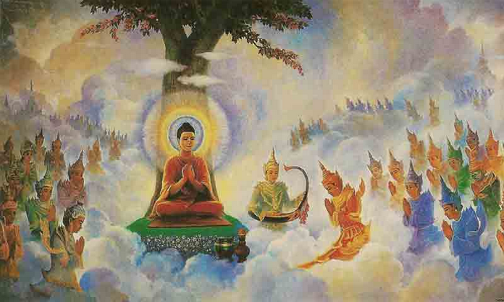 Invitation of Brahma Shampati, picture courtesy: <https://littledust.org/>

**▲ Significant events happened during that time**

**♦ First Step towards the establishment of Fourfold Assembly**

The Fourfold Assembly (catuparisā in Pali) denotes to the four groups who follow the Buddha’s teaching: monks, nuns and lay men and women. In the history of dispensation, of the Buddha, we can see that the first stone of the foundation of the Fourfold Sangha was laid during this time. This is what happened. At that time, two brothers Tapussa and Bhallika, who were travelling from Ukkalā to Uruvela, near the place of enlightenment, on an advice of a deva, made some food offering to the Buddha. After offering the meal, they paid homage to the Buddha and asked him to accept them as lay followers [43].

**Note**: In the establishment of the dispensation, the Blessed One knowing the important of disciples of monks and nuns, also encouraged lay followers to be his disciples, for their own enhancement in spirituality and also to support monastic with four requisites which is essential for their survival. We can see that During the time of the Blessed One and after his passing away- up to the present time, due to the unwavering support of lay devotees, the dispensation of the Buddha still continues to grow and shine in the world!

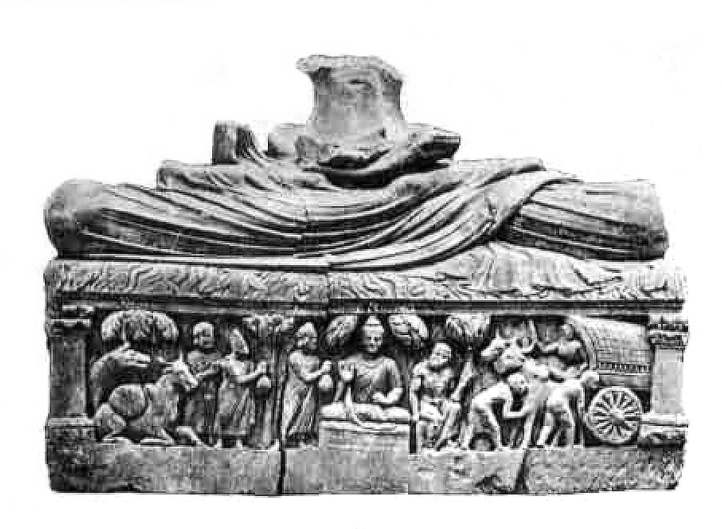**Tapussa and Bhallika**, **offering food to the Blessed One**-Peshawar Museum: Picture courtesy: Wikipedia.

▲ **First instance of the Devas’ and non-humans paying homage**

Often scriptures as well as legend bring stories on how devas or non-humans like Naga Kings paying homage to the Blessed One and asking question pertain to Dhamma and or listening to Dhamma discourses given by the Buddha. Earlier we saw how the Naga King Muchalinda paying homage to the Buddha. When the two brothers mentioned above wanted to offer food to the Buddha, the four great kings offered four alms bowls so the Blessed One could take his meal. [44]. We also witnessed how Brhmma Sahampati honouring the Blessed One and asking him to teach. This is also a good example to confirm one of the noble qualities of the Buddha: ‘teacher of humans and devas.

**Note: \*** In this occasion it is mentioned that the Buddhas don’t receive food with their hands, when the Blessed One was thinking of how to take the meal offered by Tapussa and Bhallika, the four great kings offered four crystal bowls. Tradition says through the psychic potency of the Buddha the four bowls became one. This was the first alms bowl Buddha carried * It is important to note that Deva’s recognising Samma Sambuddha as a supreme being of the world and helping the dispensation to enhance.

With this note we would like to conclude the section-4, pertain to the Enlightenment of the Buddha. In section 13: we will continue the story of Buddha from his first Teaching Tour, first discourse at the age of 35+ to his passing away at the age of 80, how he wandered in and around the ‘middle country’ of northern part of Jambudipa dedicating 45 years of his noble life teaching Dhamma and guiding people who wanted to be tamed towards freedom from suffering.

◙ **Summary**

* In this section we saw how the bodhisatta, with his vigour and wisdom defeated Māra and his army won the supreme Buddha hood.

* We have also mentioned the Noble qualities of a Fully Enlightened Budda to show why it is important of a Awaken Being to appear in the midst of population who have no knowledge of the true Dhamma.

* Briefly we have touched the period soon after of the Buddhahood and learned the good Dhamma teaching the Blessed One shown to the world.

**End Notes: Section 4**

1. The exact date of Buddha's enlightenment is not precisely known, as it predates written records.  It is believed to have occurred in the 6th century BCE. The most widely accepted date is around 563 BCE to 483 BCE, although different Buddhist traditions may have slightly different calculations: https://www.quora.com/
2. In this sutta the Buddha said: “I considered: ‘It is not easy to attain that pleasure with a body so excessively emaciated. Suppose I ate some solid food—some boiled rice and porridge.’ And I ate some solid food—some boiled rice and porridge. Now at that time five bhikkhus were waiting upon me, thinking: ‘If our recluse Gotama achieves some higher state, he will inform us.’ But when I ate the boiled rice and porridge, the five bhikkhus were disgusted and left me, thinking: ‘The recluse Gotama now lives luxuriously; he has given up his striving and reverted to luxury. **See:** MN: 36 ( Mahāsaccaka Sutta)
3. The Group of five left the bodhisatta about the new moon day of Cita (April) and moved to Migadaya, the Deer Park. See: The Group of Five: The Great Chronicles of Buddhas by Venerable Mingun Sayadaw.
4. This refers to the noble state of an arahant: see: AN1:41-50 & AN:6: 77.
5. AN5:196 (Dream sutta**): see** also notes regarding this: AN: Notes: 1200 & 1201.
6. Māra is the Evil One of Buddhism, the Tempter and Lord of Sensuality bent on distracting aspirants from the path to liberation and keeping them trapped in the cycle of repeated birth and death. Sometimes the texts use the word “Māra” in a metaphorical sense, as representing the inward psychological causes of bondage such as craving and lust and the external things to which we become bound, particularly the five aggregates themselves. But it is evident that the thought world of the suttas does not conceive Māra only as a personification of humankind’s moral frailty, but sees him as a real evil deity out to frustrate the efforts of those intent on winning the ultimate goal. The proof of this lies in his pursuit of the Buddha and the arahants after their enlightenment, which would not be credible if he were conceived of merely as a psychological projection. **See**: SN: Introduction to Sgathavagga, 4. Māra samyutta p.49.
7. Bodhi tree Ficus Religiosa (Pipal tree), The Blessed One sat under this tree and attained Enlightenment, hence it is called ‘Bodhi Tree’, meaning ‘the Tree of Enlightenment’.
8. Snp:3.2 (Padhāna sutta Translated from Pali by Bhikkhu Ñāṇamoli).
9. The story is given here: see: Offering of Milk rice by Sujata: The Great Chronicles of Buddhas by Venerable Mingun Sayadaw.
10. VP:Mahākhandaka: 4: A translation of the Pali Vinaya Piṭaka into English by Bhikkhu Brahmali.
11. Māra’s army is described as 10-fold: 1 sense-desire 2 discontent (of practice) 3 hunger & thirst 4 craving 5 dullness and drowsiness 6 cowardice 7 doubt 8 contempt & obstinacy 9 profit praise honour & fame 10 extolling of one self and scoring others. see: Snp: 3.2 (Padhana sutta, Translated by Bhikkhu Sujatho: Sutacentral Website) * In SN:4: Mārasamyutta also give detail account of Māra’s ways of obstructing the Buddha.
12. **See:** AN:2:5 * **Note:** And being dissatisfied in striving, I strove on, standing firm without retreating-Indefatigability (*appaṭivānitā*) means not turning back, not retreating. By *I strove indefatigably*, what is meant is this: When I was a bodhisatta, I strove on, not retreating, aspiring for omniscience”**see** AN:Note:221 * This determination is found elsewhere in the Nikāyas: in AN at **8:13 §8**, IV 190,8–12; MN 70.27, I 481,1–5; and SN12:22, II 28,24–28, **see** AN:Note:222.
13. **See:** DN: 14 ( Mahâpadāna Sutta).
14. MN:26.
15. **See**: SN:4:1. **Note:** Commentary (Spk) says that this sutta mentioned the first week after the Buddha’s enlightenment. **See:** SN: Notes: 260, Buddha refers to the rigorous austerities he practised for six years before he discovered the “middle way” to enlightenment: SN: Notes, 261,
16. See: AN11:11 (Mahanama sutta) & DN:3 (Ambatta sutta)
17. For detailed description of 9 noble qualities of the Buddha see:* Chapter VII Six Recollections of Visuddimagga- Path of Purification, * Suvusi Maha Gunaya (describing qualities of the Buddha, Dhamma, Sangha in Sinhala) by Venerable Rerukane Chandawimala Mahanahimi * section 5 & Buddhist Dictionary by Nyanatiloka Maha Thera.
18. This is the fourth stage of the noble path—realising the Nibbāna—arahatt-phala.
19. These three knowledges appeared at the state of enlightenment, see: MN:4 (Bhayabherava Sutta)* for more details see: DN:13 & Iti:3.5.
20. For details see: MN:4, MN:53, MN :77, DN:2, DN:3, MN:53,
21. For details see: MN:4, MN:53,AN:8:11.
22. **Source:** Ariyawamsa Dhrma Pusthaka Malava: 1-4, No1: Saptabojjangha, compile by Venerable Moratuve Siri Sasanavansa Thera (1948) * In this sutta describes Sugatha thus: “Those for whom lust, hatred, and delusion have been abandoned, cut off at the root, made like palm stumps, obliterated so that they are no more subject to future arising: they are the fortunate ones in the world” See: SN:38:3.
23. SN: 4:1. Most of the suttas in SN4: Mārasmyutta described various attempts of Māra trying to defeat the Blessed One after his enlightenment, finally, Māra the Evil One, realizing, “The Blessed One knows me, the Fortunate One knows me,” sad and disappointed, disappeared right there.
24. SN: 4:24 .
25. SN:4:25.
26. Ibid.
27. SN:4:1 **Note:** Virtue, concentration, and wisdom are the three divisions of the Noble Eightfold Path: virtue (*sīla*) includes right speech, action, and livelihood; concentration (*samādhi*), right effort, mindfulness, and concentration; and wisdom (*paññā*), right view and right intention. Māra is called the End-maker (*antaka*) because he binds beings to death, see: SN:Note:265.
28. See: VP: Mahakandhaka:1: A translation of the Pali Vinaya Piṭaka into English by Bhikkhu Brahmali.
29. The 7 weeks are described in: Chapter: 8: The Great Chronicles of Buddhas by Venerable Mingun Sayadaw, see also: <https://www.buddhanet.net/> * The popular cahnting of the “seven Weeks” : paṭhamaṁ—bōdhi pallaṁkaṁ, dutayaṁca—animmitaṁ tatiyaṁ—saṁkamaṇaṁ seṭṭhaṁ, catuttaṁ —ratanāgaraṁ paṁcamaṁ—ajapālaṁca, mucaliṁdēna—saṭṭhamaṁ sattamaṁ —rājayatanaṁ, vandētaṁ muṇi sēvitaṁ: source: https://dharmanidhaana.wordpress.com
30. “I became fully enlightened at the foot of an assattha-tree” : DN:14 (Mahâpadāna Sutta: The Great Discourse on the Lineage)
31. VP:Mahakhandaka: 1 The account with the Bodhi tree: Theravāda Collection on Monastic Law’: A translation by Bhikkhu Brahmali.
32. Full formula of the dependent origination is given in SN12: 1 & 2 .
33. SN22:10 (Gotama the Great Sakyan Sage sutta)
34. See: SN: Note: 13, p. 937.
35. In Dhammachakkapavthtana sutta (SN) we can see similar expression regarding awakening.
36. * See: VP:Mahakhandaka: 1 * See also: Ud: 1.3 (Translated from Pali by Bhikkhu Sujato, ww.w.suttacentral.net.
37. See: VP:Mahakhandaka: 2.
38. See: VP:Mahakhandaka: 3. This event also mentioned in Ud: 1.4 (Translated by Bhikkhu Sujato: [www.suttacentr.net](http://www.suttacentr.net).)
39. See: SN6:2 (Reverence sutta).
40. See: VP: Mahākandaka :5 The account of the supreme being’s request: Translated by Bhikkhu Brahmali. This event is also mentioned in MN: 26 (Ariyapariyesena sutta)
41. **See:** MN:26. This event is also mentioned in SN 6:1 .
42. See: VP: Mahākandaka :5 The account of the supreme being’s request: Translated by Bhikkhu Brahmali
43. These 2 brothers took the refuge of the Buddha and the Dhamma as that time there was no established sangha. See: VP: Mahākandaka :4 The account with the ape-flower tree: Translated by Bhikkhu Brahmali. In AN1:248 the Buddha declared them as the first lay people to take refuge of Buddha and Dhamma.
44. See: VP: Mahākandaka :4 The account with the ape-flower tree: Translated by Bhikkhu Brahmali